Abstract
Medical Tourism (MT) is a young industry that has shown promising growth in the last decade or so. Patients often travel abroad to seek treatment, conventional and otherwise due to a myriad of reasons. These include but are not limited to rising costs in their home country, experimental treatments only available abroad or better standards of care. However, MT has also created room for intermediaries to grow. These intermediaries are known as medical tourism facilitators (MTF), and as the name suggests, they provide patients services to make their experience easier and more convenient. MTFs often under deliver on their claims to the detriment of the patient. Given the varying legal jurisdiction, the sensitive nature of the healthcare process, and the arduous process of seeking and claiming settlements, most medical tourists are unlikely to pursue cases where they’ve been cheated. In order to fully understand the value chain of MT and the key issues faced by stakeholders, we used Value Focussed Thinking (VFT) to arrive at the fundamental objectives that need to be addressed for mitigating these problems of MT. Based on the findings of VFT, we propose a solution which is based on Blockchain. In order to increase disintermediation, transparency, and trust while reducing the time, effort and expense required to settle disputes, our solution automates disbursement of payments and enforces mutually accepted agreements through Smart Contracts. A prototype is presented using Hyperledger to provide clarity on the proposed blockchain solution.

Keywords: Blockchain, Medical Tourism, Smart Contracts, Disintermediation, Value Focussed Thinking (VFT), healthcare

Introduction
Medical tourism refers to the phenomenon of patients travelling from their home country to another country in order to seek or avail medical and allied services and facilities (Connell, 2006). While there are several reasons driving the growth of medical tourism, it has been observed that the main reason people opt to travel to other countries for treatment is economic in nature (Connell, 2013). High costs of medical services in developed countries has led to a rise in the influx of medical tourists in developing economies like India, Thailand and Mexico. According to Patients Beyond Borders(“Medical Tourism Statistics & Facts | Patients Beyond Borders,” 2011)the market for this industry is believed to be worth USD 65-87.5 billion, approximated from a survey of over 20 million cross-border patients. Patients are believed to be spending USD 3410 per visit. According to a report issued by VISA and Oxford Economics (“(“Medical Tourism Industry Valued at $100B Poised for 25% Year-Over-Year Growth by 2025,” 2016) , the industry will grow 25% each year for the next 10 years and “three to four per cent of the world’s population will travel internationally for healthcare and health-related treatment.”. Such an influx is beneficial for the economy of the host nation as patients usually travel with one or more attendants and bundle in tourist activities alongside their medical treatment (Beladi, Chao, Ee, & Hollas, 2019). The growth of medical tourism has thus led to the development of new business opportunities focussed solely around this premise. For example, there has been an emergence of intermediaries called medical travel facilitators (MTFs) who offer packages for medical tourists which are priced differently for different target segments (Mamun & Andaleeb, 2013). These packages not only include arranging for suitable doctors, hospitals and labs but also for accommodation, food and other hospitality needs (Carrera & Bridges, 2006).
However, the rapid growth of this industry creates opportunities for these MTFs to induce fraudulent practices based on information asymmetry that exploit patients (Gan & Frederick, 2011). Medical tourists often have little knowledge about the host country, which makes them susceptible to unscrupulous MTFs. Facilitators may also swindle medical tourists by providing services which are inferior to the standard agreed upon (Gan & Frederick, 2011). Differing legal standards, jurisdictions and oversight further complicate matters and leave the customers with little scope for recourse or resolution of their grievances (De Arellano, 2007). Thus, there is a pressing need to create an auditable system which is transparent and provides a robust mechanism for resolution of conflicts and transfer of payments.
In order to understand the problem at hand more clearly, we employed Value-Focused Thinking (VFT) (Keeney, 1993), which is a proactive mechanism of problem structuring. We identified the major stakeholders of our system as doctors, patients and MTFs with whom we initiated the process of VFT. From our extensive discussions, we realised that stakeholders need a reliable system that can be mutually trusted by all parties. In case a mutual agreement is violated, punitive measures such as a denial of payment or penalty charges must be levied in a transparent and acceptable manner. The identities of the participants in this system are also essential. As this is a trust-based network, doctors, hospitals, facilitators and patients should all have verifiable and legitimate identities and details so that the system is auditable. After identifying these objectives, we found that the solution requirements based on objectives closely align with a blockchain technology-based solution.

A blockchain is a distributed ledger technology which provides immutable storage of records known as transactions (Nakamoto, 2008). While blockchain offers several benefits, we shall discuss those that are germane to the context at hand. Blockchain is a distributed ledger, which means that it is decentralised. The obvious benefit that this provides is robustness and security, as there is no single point of failure (Ølnes, Ubacht, & Janssen, 2017). For our present context, this is important as medical records and bank transactions are data of sensitive nature. The next core feature of blockchain that is of immense importance is the ability to accommodate various parties by increasing their participation in the system and establishing trust. This is a direct consequence of the consensus mechanisms that blockchains apply while vetting new transactions. A proportion of the nodes on the network have to respond affirmatively in order for new transactions to be added. This proportion changes from implementation to implementation (Baliga, 2017). Another important feature of blockchain that has contributed to its popularity is its ability to track commodities (money, documents, and so on), and maintain an auditable history of the same. This enhances transparency within the system and in case of any abnormal behaviour, the system can be readily queried to locate flaws (Nguyen, 2016). Finally, the most relevant feature of blockchain is perhaps its ability to automate the execution of “Smart Contracts”. This contributes towards increasing disintermediation, while at the same time eliminating the economic costs and risks that are associated with middlemen (Mattila, 2016).

Keeping in mind the objectives identified, we propose a blockchain based system that would greatly improve transparency and reduce trust issues within the Medical Tourism Value Chain. The main problem that we aim to tackle is curbing fraudulent practices by the multiple facilitators and other middlemen. We present a prototype of blockchain where stakeholders are involved in the value chain to mutually acceptable predetermined conditions that will dictate the functioning of different operations in the medical tourism ecosystem. This ensures that a customer cannot be deceived by an intermediary, doctor, service provider or caregiver. This also allays fears of the service providers, as they are guaranteed payment from the customer in a transparent fashion. The payment is only conditional to their own ability to deliver on the terms previously mutually agreed upon. This entire process would be governed through mutually acceptable predetermined conditions often called Smart Contracts or Chaincode in the blockchain network.

In section II, we will discuss the economic importance of medical tourism, as an industry. We will also explore the role of MTFs within this industry and try and examine their net effect on the status quo. In section III we aim to understand the problem in-depth by analysing the responses of stakeholders. Using the VFT approach we will attempt to frame objectives and goals for a viable solution. In Section IV we look at blockchain technology in depth. We discuss the evolution of blockchain technology beyond crypto currency, its present adoption across different problem contexts and discuss the types of blockchain architecture that most suit our present context. Section V will briefly summarise our research methodology. While in section VI we shall discuss our proposed solution in depth and in section VII present our prototype, before concluding this literature with comments on limitations and future work in our conclusion in section VIII.

Medical Tourism

Health Tourism can be described as the delivery of health care through the consumption of natural resources such as climate and water of a particular country. International Union of Tourist Organizations (IUTO) defined Health Tourism as ‘‘the provision of health facilities utilizing the natural resources of the country, in particular, mineral water and climate’’ (Smith & Puczko, 2008). Health tourism was presented as the organized travel that people take outside their local environment to maintain, enhance or restore their mind and body’s wellbeing (Carrera & Bridges, 2006). Medical tourism is a fragment of health tourism where a patient can avail medical facilities from providers outside their own legal system to supplement or reinstate their health (Carrera & Bridges, 2006).

In the medical and health studies literature, medical tourism simply refers travelling to a remote country with the purpose of availing medical facilities (Balaban & Marano, 2010) and is paid out of their own pockets (Crooks, Turner, Snyder, Johnston, & Kingsbury, 2011; De Arellano, 2007). Consumption of tourism services such as recovering in resorts while availing cross-border care is associated with the experience but it cannot be considered as a fundamental part of medical tourism (Connell, 2006; García-Altés, 2005; Marlowe & Sullivan, 2007; Turner, 2007; Whittaker, 2008). Thus, medical tourism essentially implies travelling for active medical intervention for health restoration.

Medical tourism hospitals provide a wide range of procedures including various elective surgeries as well as emergency procedures (Ehrbeck, Guevara, & D Mango, 2008; Heung, Kucukusta, & Song, 2010). The Medical Tourism Association estimated a USD 100 billion market based on the estimated annual growth proposed by Deloitte in 2008. Patients Beyond Borders estimates the market size to around USD 65-87.5 billion, based on approximately 20-24 million patients crossing international borders to get medical care worldwide (“Medical Tourism Statistics & Facts | Patients Beyond Borders,” 2011). The expected compounded annual growth rate (CAGR) for the global medical tourism industry is forecasted to be approximately 14.9% for the span of 2017-2025 (“Medical Tourism Market - Global Industry Analysis, Size, Share, Growth, Trends, and Forecast 2017 - 2025,” 2017). The Transparency Market research company has estimated the market value of medical tourism industry by the end of 2025 to be USD 160.8 billion (“Medical Tourism Market - Global Industry Analysis, Size, Share, Growth, Trends, and Forecast 2017 - 2025,” 2017).
From past literature, five distinct motivations can be recognized for individuals seeking medical treatment abroad. They are summarized as follows:
- Economic Cost Dimension: The medical services exposed by hospitals facilitating medical tourism may be cheaper than the services available in the patient’s home country (Ferrer & Medhekar, 2017; Milstein & Smith, 2006). The cost savings become a crucial factor in travelling long distances in search of affordable medical care (Burkett, 2007; Connell, 2006; De Arellano, 2007; Unti, 2009).
- Time Cost Dimension: The availability of medical services in a timelier manner within the destination country (Eggertson, 2006; MacReady, 2007). Patients heading from countries like Canada and much of Europe where medical care is publicly funded want to avoid long waiting times.
- Regulatory Cost Dimension: Existence of the legal jurisdictions restricting the access to medical procedures promotes medical tourism (Korcok, 1997; Mudur, 2003).
- Commercial Behavioural Dimension: Medical tourism also comes with an advantage of getting treatment while enjoying holidays at a relatively exquisite location (Mudur, 2003).
- Availability Dimension: The unattainability of an organ for transplant in medical tourist’s home country can lead to a search of medical services in cross border countries (Bramstedt & Xu, 2007; Hall, 2011).
The medical tourism industry plays a significant role for its stakeholders and its value chain can be explained in three stages (Keckley & Underwood, 2008). In the preprocedural stage, the tourist must take several decisions, including the choice of medical travel facilitator, medical providers like hospitals or physicians or doctors as well as the destination country. These decisions are influenced by various factors such as total cost, convenience in availing medical treatments as well as the risks associated with it. Many tourists prefer to use the services of medical facilitators who provide convenience and seamless coordination during outbound medical tourism programme. Second stage which is the procedure stage begins once the patient reaches the destination country. The medical travel facilitators offer convenience through pick and drop facilities from the airport. Before the medical treatment commences, the service providers arrange for counselling and prerequisite medical reports. The post procedure stage takes place in two halves, the post-operative care and the follow-up care. The post-operative care segment takes place when the tourist is still in the destination country and includes doctors’ visits, recuperation in medical institution, medical supplies, meals and relaxation package. The follow up care is provided by the hospitals in the customer's home country who are in partnership with cross border service provider.

The medical tourism value chain is a nexus of stakeholders that are responsible for the organization, funding, and distribution of medical services, in conjunction with the management of information flow and finances dispensation within the value chain (Ferrer & Medhekar, 2017). Trust between the stakeholders along with commitment and mutual understanding form the main drivers of the medical tourism value chain. The participants of medical tourism supply chain can be categorized into medical tourists, medical travel facilitators and medical service providers. Information sharing between the upstream and downstream suppliers within the value chain plays a crucial role in medical tourism industry (Lee & Fernando, 2015). The upstream suppliers are responsible for the provision of services/products for medical tourism (e.g., accommodation, airlines, hospitals). The downstream suppliers help in boosting the sales of these services/products of medical tourism (e.g., medical travel facilitators).

Collaboration and cooperation within the entire value chain along with sharing of authentic information are the key aspects identified for the sustainability of medical tourism supply chain (Lee & Fernando, 2015).
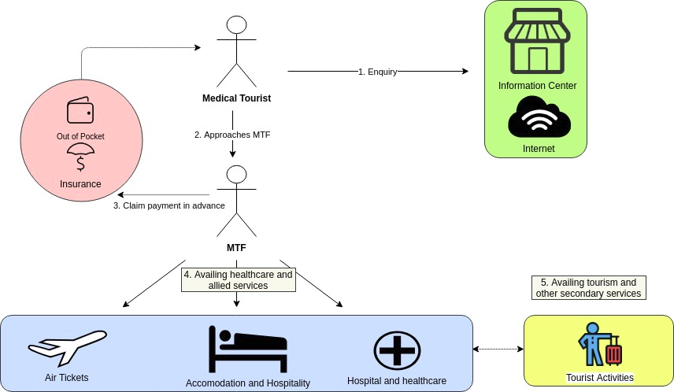
Fig 1. The Medical Tourism Value Chain

Value-Focused Thinking
According to Keeney (Keeney, 1993), conventional approaches to decision making first focus on discerning alternatives (any suitable course of action) that are generated out of intuition. These alternatives are then evaluated using some objectives and criteria, which may be arbitrary in nature. Keeney states that, in typical scenarios, people tend to view decision situations as decision problems (Keeney & McDaniels, 1992). Such decision problems are usually imposed on people by uncontrollable circumstances (recessions, natural disasters) or circumstances created by others (competitors, customers, government, stakeholders) (Keeney, 1994). A problem first appears, and then the alternatives that are inherently attached to the problem are discussed. The next step is to rank these alternatives by considering some criteria to evaluate them. Thus, this conventional approach is reactive in nature, and is termed as alternative-focused (Keeney, 1994). It gives little room to determine preferences among alternatives or to discover new alternatives altogether. It emphasizes on identifying alternatives before articulating values. However, it is important to recognize that alternatives are just means to realize values (Keeney, 1994), which are more fundamental to any decision situation.

In order to address the limitations of alternative-focused thinking, Keeney advocates a proactive approach, called Value-Focused Thinking (VFT), with more focus on values than alternatives. Values help in determining the desirability of alternatives and their consequences. However, inchoately generated alternatives may only satisfy a few of all the values. A decision maker’s goal should be to incorporate as many values as possible while dealing with the decision situation. VFT, where values are articulated first, and then used to improve the decision-making process, helps to develop alternatives that align better with the strategic goals (Keeney, 1994). Through the process of articulating values, VFT facilitates the collection of information from stakeholders that is particularly useful and pertinent to the decision situation. It also helps unearth objectives and alternatives that would otherwise remain out of the scope of identification. An iteration between generating alternatives and articulating values is recommended, with primary focus on values (Keeney, 1994). Once we have a presumably exhaustive list of values or objectives, we look to evaluate each one using attributes. Subsequently, this list of objectives is used to generate alternatives, some of which may be novel and unique. One strategy to generate alternatives is to consider alternatives that help fulfil a single objective, followed by alternatives that fulfil combinations of objectives. This will help develop an all-round solution space.

Thus, VFT provides a framework to develop appropriate solutions to decision situations. It allows us to view these situations as decision opportunities rather than decision problems, by letting us integrate fundamental values while developing alternatives.

VFT can serve as an excellent tool when complex decision-making and large organizations are involved. British Columbia Hydro and Power Authority, a Canadian power supply giant, faced many such complex strategic decisions (Keeney & McDaniels, 1992). Applying VFT to address these complexities resulted into “…a significant influence on the thinking of senior planners regarding the nature of objectives, trade-offs, and decisions.” In a different study (Selart & Johansen, 2011), alternative-focused thinking and value-focused thinking were both employed in idea management. Using a sample of employees, the impact of the two approaches was assessed. The results showed that Value-Focused Thinking led to the formation of fewer ideas. However, these ideas were found to be of a better quality with respect to creativity and innovation. In a study about Information Security in organizations (Dhillon & Torkzadeh, 2001), Value-Focused Thinking was applied to broaden the perspective about information security considerations by including the values of people from an organizational perspective. The results indicate that a decision situation that conventionally only concerned technical aspects could be better dealt with by including organizationally grounded values and principles through VFT.

The value chain of medical tourism involves numerous stakeholders. We presume that each stakeholder must have a different set of values that they would use to appraise the functioning of the process. The same values shall be used to judge the quality of their experience with the process. We believe that the values directly put forth by the stakeholders triumph our own personal idea of a ‘good system’ in terms of utility and viability. These values will lead us to alternatives that are more fitting and suitable to the problem than the obvious and intuitive ones. Thus, we view the decision situation as a decision opportunity, aiming to generate better, unforeseen alternatives. This will help us develop a solution that integrates the fundamental values of all stakeholders, and especially the patients. Hence, we go with VFT in our project.

In order to understand the perspectives of stakeholders, we performed in-depth discussion with them. Through these discussions with stakeholders, and the help of past research work relevant to our context (Martínez Álvarez, Chanda, & Smith, 2011), we were able to arrive at a set of values for establishing a robust system to cater to the needs of the MT value chain. Values contain within themselves useful information regarding objectives, criteria, goals and constraints, but these must be extrapolated and framed in a constructive manner (Shukla, Mohanty, & Kumar, 2018). The information thus derived, forms the basis of our objectives. These are then identified as either fundamental or mean objectives. While the former defines the end result to a value objective, the latter defines the means to achieve that end. In combination, they help us realise the strategic objectives, which allow us to achieve strategic goals.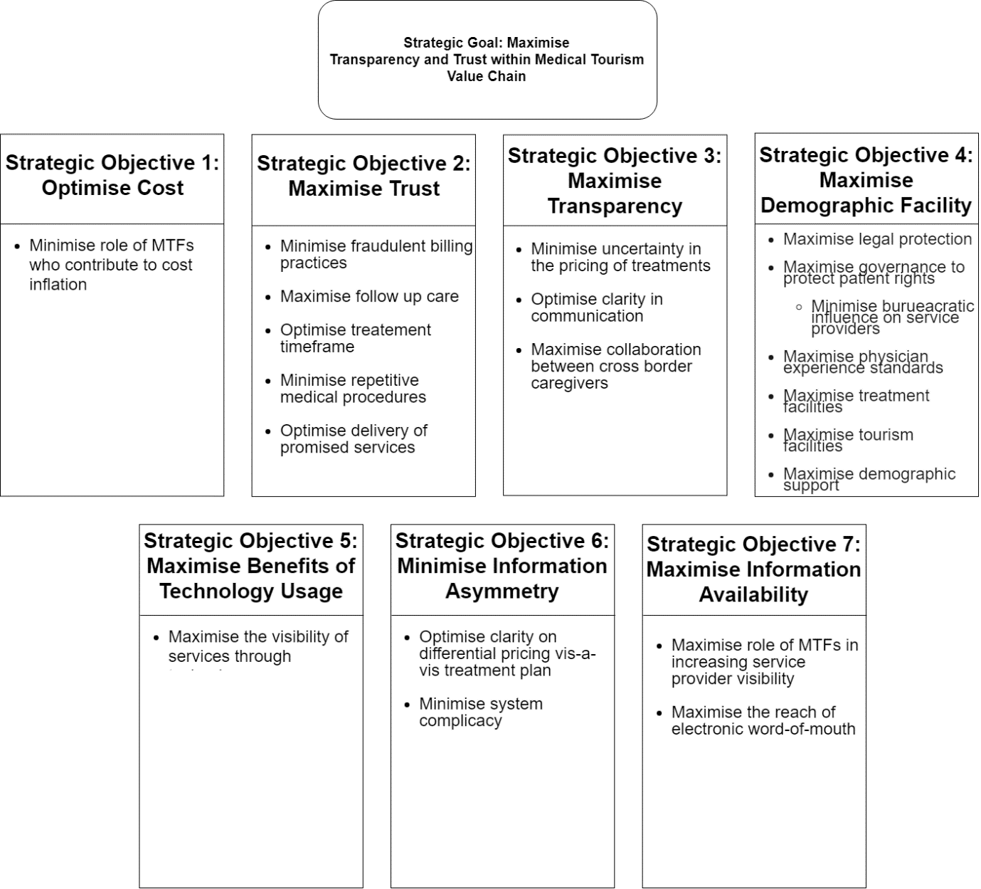

Fig. 2: Hierarchical relationship between fundamental and strategic objectives

In our present context, we identified our strategic goal as achieving a system that makes the MT value chain transparent and trustworthy. The strategic objectives, of which we identified seven are:
- Optimise Cost
- Maximise Trust
- Maximise Transparency
- Maximise Demographic Facility
- Maximise Benefits of Technology Usage
- Minimise Information Asymmetry
- Maximise Information Availability
These strategic objectives must be suitably optimised in order to meet the strategic goal described at the problem definition level. These objectives are themselves driven by fundamental objectives which are holistically representative of the set of values from which they derived. In our problem context, these values revolve around cost and time invested for treatment, transparency and trust between stakeholders, the role of demographic factors such as governance, bureaucracy and infrastructure and finally the flow of information. These fundamental objectives are themselves achieved from a matrix of mean objectives. Having discussed the VFT process employed, we present the hierarchical representation of our strategic objectives.
Fig. 2 describes how fundamental objectives map to strategic objectives which in turn achieve the strategic goals. Meanwhile, fig. 3 describes how fundamental objectives are discovered using mean objectives where one or more mean objectives can drive a fundamental objective. Thus, we illustrate the application of VFT to resolve trust and transparency issues in the MT value chain.
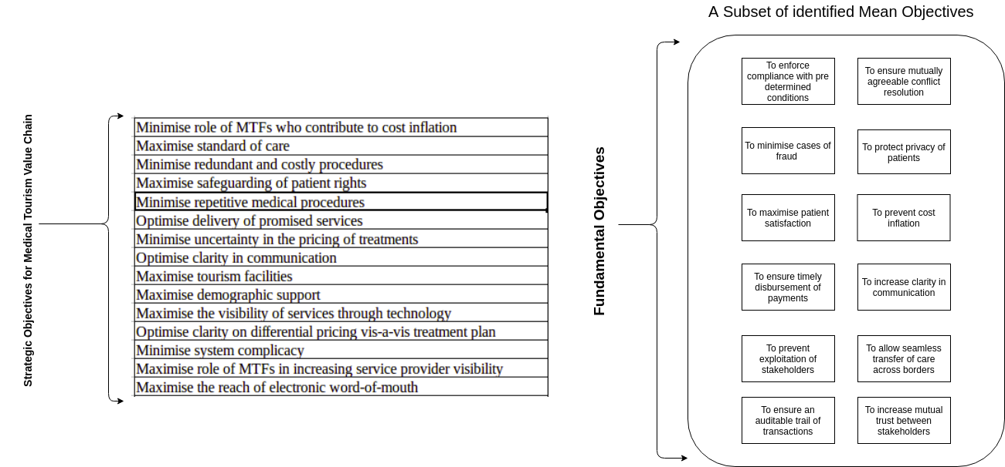 Fig. 3: Deriving fundamental objectives from mean objectives.

The VFT approach is only as effective as the identification of stakeholders. Therefore, it is pertinent to note that if a certain stakeholder is left unaddressed, an entire set of values may end up being ignored (Morais, Alencar, Costa, & Keeney, 2013). Consequently, the set of fundamental objectives and strategic objectives derived from the former would not be exhaustive, and the strategic goal identified may not cover the needs of all stakeholders.

Blockchain
The underlying technology behind Bitcoin, blockchain is a public, distributed ledger which stores immutable records that maintain information about transactions that occur on the peer to peer network (Nakamoto, 2008; Yli-Huumo, Ko, Choi, Park, & Smolander, 2016). Since the emergence of Bitcoin in 2008, applications of blockchain have been widely discussed, both in academia and industry and several practical use cases have been implemented across domains. In this section, we will briefly discuss what exactly a blockchain is, its architecture, how it has evolved as a technology since 2008, its application beyond cryptocurrency and finally its potential to disrupt medical tourism.
As previously mentioned, blockchain is a distributed ledger that was developed by Satoshi Nakamoto in 2008 as the basis of the cryptocurrency Bitcoin (Nakamoto, 2008). It was argued that using cryptocurrency and blockchain, one could arrive at a system in which money would go from one party to another party directly, bypassing a traditional intermediary entirely (Nakamoto, 2008). The underlying blockchain was equipped with the necessary cryptographic capabilities to maintain the immutability, order and integrity of the involved transactions (Peterson, 2018). The purpose of this technology was thus mainly disintermediation and as a result, protecting the interests of parties involved in the transactions while eliminating costs associated with intermediation.

While cryptocurrencies dominate the blockchain landscape as a use case, the ability of blockchains to maintain transaction history transparently have encouraged applications in a variety of contexts (Crosby, Pattanayak, Verma, & Kalyanaraman, 2016). One such application is the ability of blockchains to seamlessly incorporate ‘Smart Contracts’, which truly enhanced the disruptive nature of blockchain as a technology. Smart contracts are like regular contracts, but they are programmed into the blockchain. A smart contract specifies certain conditions to be met and actions to be undertaken vis-a-vis the contingency. As a result, they can be used to automate disbursement of payments, releasing documents and so on. In particular, the ability of smart contracts to remove intermediaries and establishing trust between parties by reducing information asymmetry, is of interest and draws widespread research attention (Crosby et al., 2016).

Before proceeding to the evolution of blockchain technology, it is important to understand how blockchains function. We shall first consider the classic bitcoin blockchain, which is an example of a public blockchain (Lin & Liao, 2017). A blockchain network comprises of peer-to-peer connections between computational resources called nodes. Each node in the blockchain has a job of processing blocks of transactions. Since the nodes are incentivised to compete with each other in order to mine new blocks, there is also a mechanism to come to an agreement about which block must be added to the blockchain. This mechanism is called a consensus protocol, and in the case of bitcoin, the protocol is called Proof-of-Work (PoW) (Nakamoto, 2008). As the blockchain grows, the computational difficulty of mining new blocks increases. PoW protocol holds that miners must arrive at a hash code which is difficult to compute but easy to verify (Mingxiao, Xiaofeng, Zhe, Xiangwei, & Qijun, 2017). In order to compromise the integrity of the blockchain by modifying a past block, an attacker not only has to modify that block, but also must spend considerable resources in recomputing the work of all the blocks that follow, up until the current block, and surpass the current block as well. The combination of PoW and the incentive system ensures that it is highly impractical for an attacker to compromise the public blockchain (Lin & Liao, 2017; Nakamoto, 2008). The computational intensiveness of the public blockchain is also a drawback. Typically, public blockchains have poor performance (in terms of transactions processed per unit time) and high latency (Lin & Liao, 2017; Park & Park, 2017).

Soon, a need for identity-based blockchains was recognised that could do away with a public blockchain. This need was satisfied by permissioned blockchains. Permissioned blockchains move away from PoW by instead forming the network with only those participants that are identifiable and have permission to be part of the network. This allows participants to know each other’s identities, establishing accountability (Vukolić, 2017). The identities are established by verifying digital certificates that each participant must hold. Permissioned blockchains generally outperform public blockchains on the parameters discussed in the previous paragraph (Zheng et al., 2017). They are also more suited to problems that confront enterprises, consortia and governments. The consensus in permissioned blockchains is usually arrived at using the practical Byzantine Fault Tolerance algorithm (PFT). A comparison of the two major types of blockchains is given in table 1. (Zheng et al., 2017)

Presently, blockchains have evolved past their initial use case of cryptocurrency. According to a report commissioned by PriceWaterhouseCooper (PwC), the technology seems to have disrupted the financial industry the most. According to the report, the adoption of blockchain broken down by industries shows that the financial services lead adoption at 46%. Other industries that have adopted blockchains are Industrial Products and Manufacturing (12%), Energy and Utilities (12%), Healthcare (11%) and Government (8%). Finally, retail and consumer goods (4%) and Media (1%) round up the survey (PricewaterhouseCoopers, 2019). Some notable innovations include using blockchains to create digital identities for refugees from Syria in order to ensure a supply of nutrition to them, a project that has the backing of the UN’s World Food Program (WFP) (Zambrano, Young, & Verhulst, 2018). Perhaps the most popular application of blockchains apart from cryptocurrency has been in transforming supply chain management. In particular, agricultural supply chains, from farm to fork have already been transformed by the adoption of blockchains. For example, Walmart and IBM have come together in order to enhance food traceability (Galvin, 2017).

Another key domain disrupted by blockchains is the healthcare industry. Data pertaining to medical records of patients is highly confidential and sensitive in nature (Mettler, 2016). The consistency and integrity of a patient’s medical history are often critical to arriving at the correct diagnosis and the subsequent treatment of the patient. In such a scenario, blockchains offer immutability, ease of sharing data securely, and data integrity. The problem and a comprehensive solution are discussed in “MedRec: Using Blockchain for Medical Data Access and Permission Management”(Azaria, Ekblaw, Vieira, & Lippman, 2016). Finally, the ability to execute smart contracts has been of immense importance to the financial services sector. In particular, smart contracts allow for speedy settlement of conflicts, provide an auditable trail for financial transactions and are inured to tampering (Peterson, 2018). Disintermediation in medical tourism involves a combination of all the advantages associated with blockchain technology discussed so far. Not only would blockchains ensure medical and financial data is keenly protected, but they would also maintain access control and history associated with that data which allows for simpler audit processes. The ability to execute smart contracts when certain predetermined conditions are met will increase disintermediation and improve trust between the stakeholders. For these reasons, permissioned blockchains were considered a possible alternative to the mechanisms that currently operate in medical tourism.

Research Methodology

The research methodology applied in this literature to understand, amend and improve the MT value chain is primarily composed of the following steps:

1. Understand the current Medical Tourism Value chain
2. Identify all the stakeholders
3. Apply VFT to identify fundamental objectives in order to derive strategic objectives, and subsequently, the strategic goal.
4. Study the suitability of Blockchain Technology to achieve strategic goals
5. Develop a prototype to achieve strategic goals

Fig 4 depicts the flow of these steps into one another. Based on sections already covered by this work, we will briefly discuss the modalities concerned with each step.

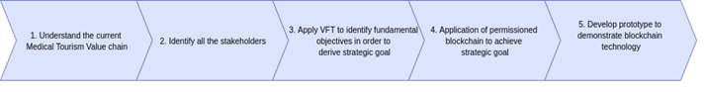
Fig. 4
Understand the current Medical Tourism Value chain
To understand the problem at hand, we had to first identify the context of the industry in which the problem exists. In order to do so effectively, we had to survey literature pertaining to the definition, nature, working and drawbacks of the present system. We also formally spoke to professionals working within the industry.

Identify all the stakeholders
After understanding the value chain associated with MT, we had to identify all actors, processes and organisations directly and indirectly affected by and associated with the present system. Since these parties are associated with MT most closely, any viable solution would affect them the most and it is extremely pertinent to understand their perspectives and concerns before embarking on finding a solution.

Applying VFT
We conducted interviews with stakeholders independently of the work previously cited in order to access as much information as possible. With the help of work that applied VFT to other contexts (Shukla et al., 2018), as well as the work done previously on collating responses from medical tourists (Martínez Álvarez et al., 2011) we were able to employ VFT to our problem context.

Application of Blockchain Technology
With abundant literature available on the applications of blockchain technology (Mattila, 2016), and inferring from the findings of VFT, we were able to identify blockchain technology as a suitable solution.

Development of Prototype
After employing VFT and arriving at the strategic goals, via framing our fundamental (ends) and mean objectives, we were able to map our corresponding technical objectives as they applied to the blockchain based solution. Based on those, we constructed our prototype using the Hyperledger framework, in order to demonstrate the efficacy of the blockchain technology as a viable solution.

Proposed Solution

After studying the current state of affairs of the industry, it was established that it is affected by two major problems. First, the existence of MTFs creates opportunities to deceive foreign patients due to an information asymmetry. This can be further exacerbated by the geographical, cultural and legal differences between the patient’s home and destination countries. Second, medical providers in the destination country also participate in fraudulent practices like price inflation, while leaving the patient with little opportunity for recourse (Hopkins, Labonté, Runnels, & Packer, 2010). Fundamentally, these opportunities have arisen because of the information asymmetry that exists between the patient, and the providers and MTFs. Through discussion with the stakeholders involved in the value chain and applying the principles of VFT, we arrived at the inference that most of these practices can be curtailed by an infrastructure that enables transparency and mutual trust between the patients and the providers (Lee & Fernando, 2015). Blockchain being a technology that inherently promotes transparency due to its decentralized character, was identified as something that could help in addressing the problems in the medical tourism industry. Furthermore, a permissioned blockchain suits our case more than a public one because of the need to improve trust between the stakeholders. We now propose and present a prototype build on Hyperledger Fabric, a permissioned blockchain framework

Hyperledger Fabric
Hyperledger Fabric is a plug and play style blockchain framework, developed mainly by IBM. (Androulaki et al., 2018). It allows you to build a flexible and modular solution architecture. Certain components like membership protocols and consensus can be implemented in an ad-hoc fashion. Fabric is also a permissioned blockchain platform, which means that the different identities in the network are known among participants and joining the network is contingent on being able to identify as one of the predetermined identities. This permissioned organization of blockchain networks provides higher levels of confidentiality of data and privacy, when compared to public blockchains. What makes Fabric suitable for wide-ranging industry applications, however, is its high scalability, as demonstrated by Change Healthcare’s Fabric implementation of a blockchain based solution for claims lifecycle management. The system is claimed to be handling fifty million transactions per day, or 550 transactions per second (“Change Healthcare Case Study,” 2019)

We now propose and present a prototype of our solution, which is based on Hyperledger Fabric, a permissioned blockchain architecture. Hyperledger Composer, a tool that simplifies the creation of complex Fabric applications, is used to develop and deploy the business network (business logic of the application) to the Fabric blockchain nodes. Components of Hyperledger composer include the Blockchain Ledger, which stores all transactions submitted through a business network, and the Blockchain State Storage, which stores the current state of all assets and participants in the network. Both the ledger and the state database are distributed across a set of peers. A consensus protocol ensures that updates to both are consistent across all peers in the network.
The web interface is designed using Angular, a JavaScript based front-end framework. It interacts with the network through the Composer Rest Server, an application that provides Application Programming Interfaces (APIs) to deploy transactions (Chaincode) to the Fabric network. Fig. 5 shows a list of APIs available for this application. The presented prototype is tested on an Ubuntu (Linux) based machine with an Intel 5th generation 8265U octa-core CPU running at 1.6 GHz clock speed, with 8 GB of RAM.
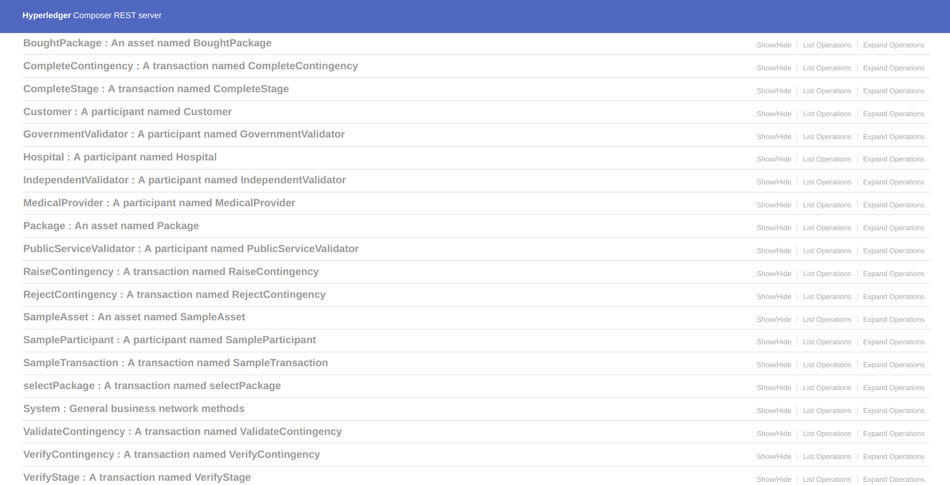
Fig. 5: APIs generated by the Composer REST server

Our solution aims to create a common space shared by all participating medical providers that make available medical procedures (package) for foreign patients. Whenever a patient opts for any of the procedures provided by a medical provider, they enter into a mutual agreement with the provider, dictated by the Chaincode (smart contracts) written into the Hyperledger Fabric based network. This Chaincode, as the first step in the cycle, puts the payment made by the patient in escrow, in the form of a Hyperledger Composer asset belonging to the patient. Controlled by the Chaincode, the subsequent disbursement of money occurs in stages, and it is contingent on completion of the procedure pertaining to that stage. This is facilitated by a mutual verification mechanism written into the Chaincode.

Many medical treatments that medical tourism patients usually opt for can have certain procedures, whose requirement could not have been realized at the beginning of treatment. Such procedures are referred to as contingency procedures. To accommodate such procedures, a contingency fund is set aside in escrow whenever a patient opts for any treatment package. This fund is to be spent on one of the prelisted contingencies, or one whose requirement have arisen during treatment. However, making the patient undergo an unnecessary treatment for purely monetary gains is one of the ways medical providers often deceive patients. To curb this, the network may include some third-party participants who are designated with the job of validating the legitimacy of new contingency procedures suggested by a medical provider. In case such a procedure is rejected by a validating party, the provider can be penalized, and the procedure cost refunded to the patient, along with a reimbursement. Such validating authorities can include professionals from the industry or academia, government officials, or volunteers from non-government organizations. However, incentivization is necessary to sustain this mechanism. Fig. 8 shows a general overview of the model.

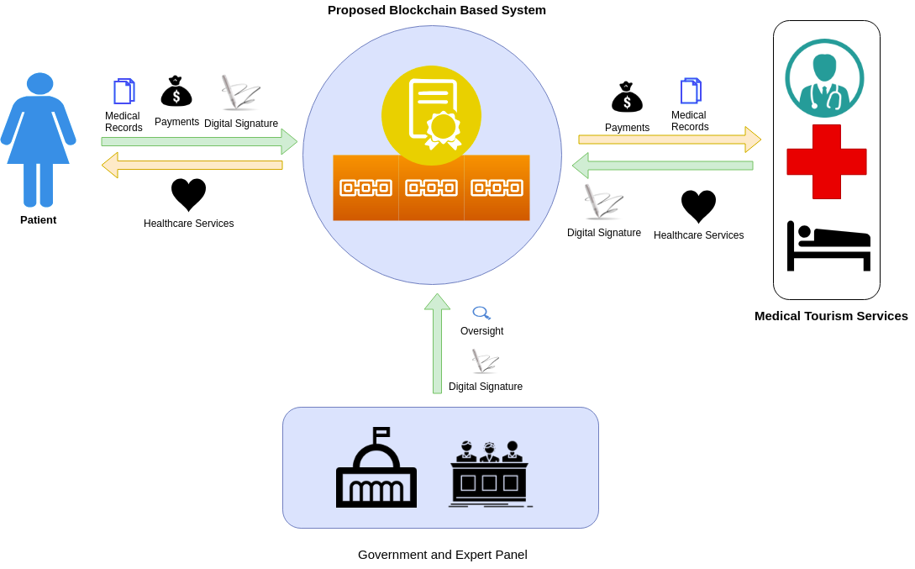
Fig. 6: A general overview

The participants of our system include:

- Medical Provider: This role can be fulfilled by any medical service provider. Complete medical treatment packages will be put up by the medical provider, which exist in the form of Composer assets (Fig. 7). This participant has the following functions:
- Verify completion of a stage: After completion of the procedure corresponding to any stage, the provider will verify completion of the procedure from their side. This is the first step in the mutual verification procedure that will happen for every stage in the package (Fig. 8). However, verification is completed only after the patient also verifies it.
- Raise a contingency procedure: Whenever, during the treatment, there is a need for a medical procedure that was not known beforehand, the provider can raise a ‘contingency procedure’. This procedure also undergoes the same mutual verification mechanism as for the other, pre-listed stages (Fig. 9). For this kind of medical procedures, verification operation from the provider side is included with the raise contingency operation.

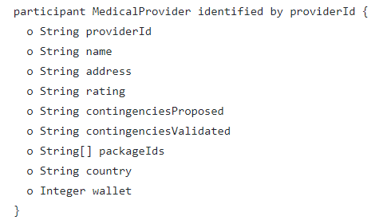
Fig. 7: Definition of the Composer asset for medical provider

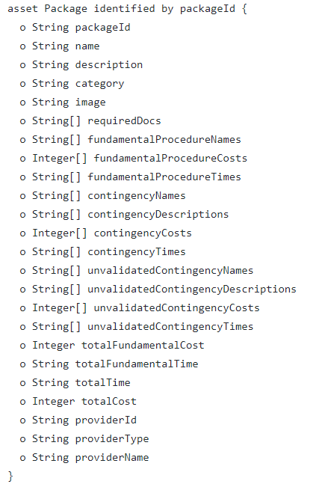
Fig. 8: Definition of the Composer asset of a treatment package
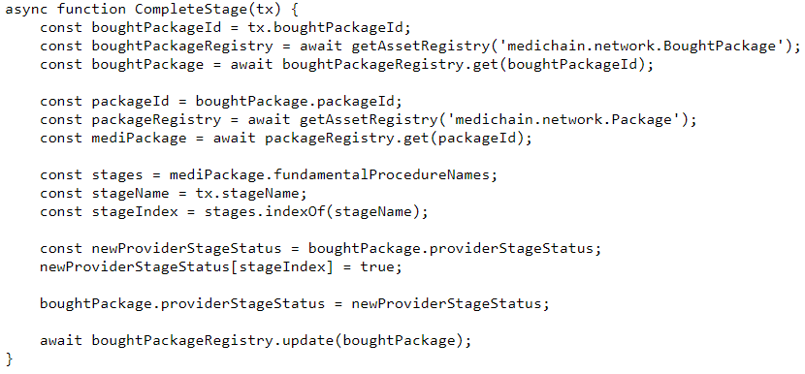
Fig. 8: Chaincode for verification of a stage by medical provider

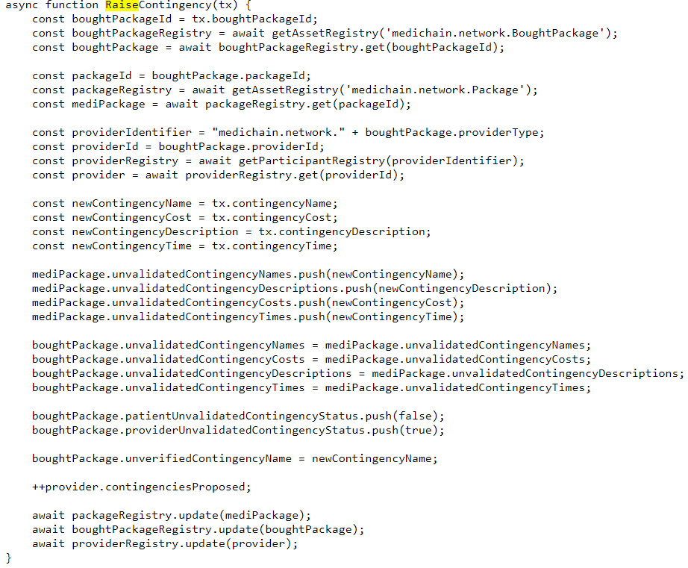
Fig. 9: Chaincode for raising a contingency by medical provider

- Patient: Any common citizen can register as a patient, designated as ‘customer’ in the system, and opt for a treatment package put up by one of the medical providers. Once a package is bought, the entire cost of the package is held as escrow in a Composer asset (Fig. 11). An additional contingency amount, for contingency procedures is also put into this asset as escrow. Apart from the funds, the patients’ medical records will also be uploaded and stored as a part of this package. This participant has the following functions:
  - Verify Completion of Stage: After the verification of completion of a stage by the medical provider, the patient must also verify it for successful completion. This will result in the transfer of appropriate funds from the escrow to the medical provider’s wallet (Fig. 12).
  - Verify Completion of Contingency: Just like a normal, pre-listed stage, a contingency stage must also undergo mutual verification, the second part of which is the verification by patient (Fig. 13).

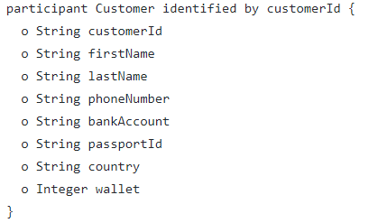
Fig. 10: Definition of the Composer asset for patient (customer)

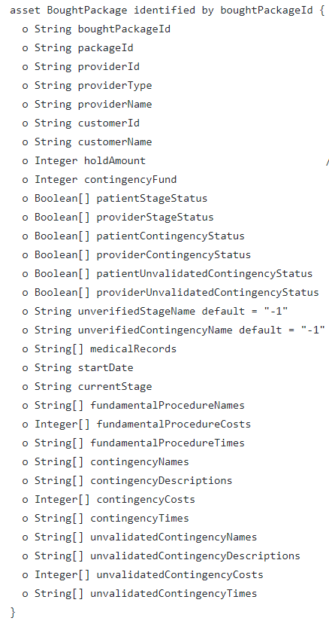
Fig. 11: Definition of the Composer asset for a package after it is purchased

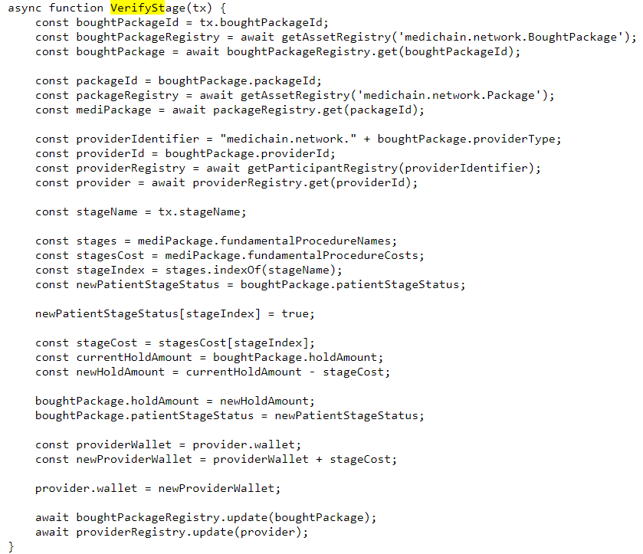
Fig. 12: Chaincode for verification of stage by the patient

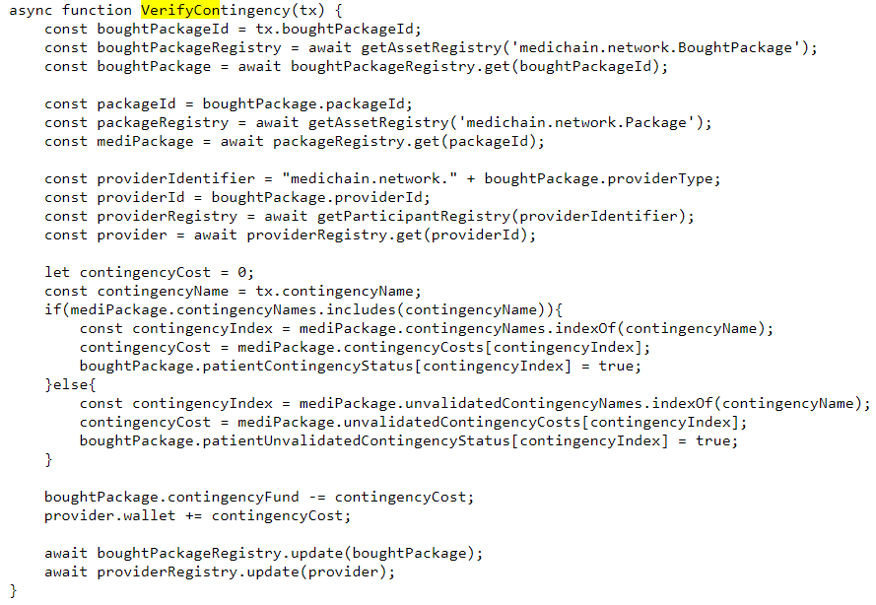
Fig. 13: Chaincode for verification of contingency by the patient

- Validator: This role can be fulfilled by a trusted and verified third party (Government representative or independent practitioner) and has the responsibility of confirming or denying the validity the contingency procedure raised by a medical provider. Their participation may have to be incentivised with monetary, or other kinds of rewards. Their functions include:
  - Validate Contingency: When a validator deems a contingency procedure, yet to be validated, as justifiable and sound, it can formally validate it through the interface. Chaincode for the same is shown in Fig. 15.
  - Reject Contingency: When a validator does not deem a contingency procedure as justifiable or valid, it can formally reject it through the interface. This will result into the levying of a penalty on the medical provider. This also makes the patient entitled to a reimbursement amount, which will be transferred to the escrow. Chaincode for the same is shown in Fig. 16.

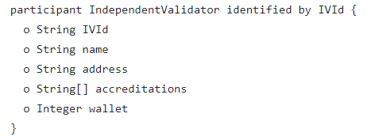
Fig. 14: Definition of the Composer asset for third-party validator
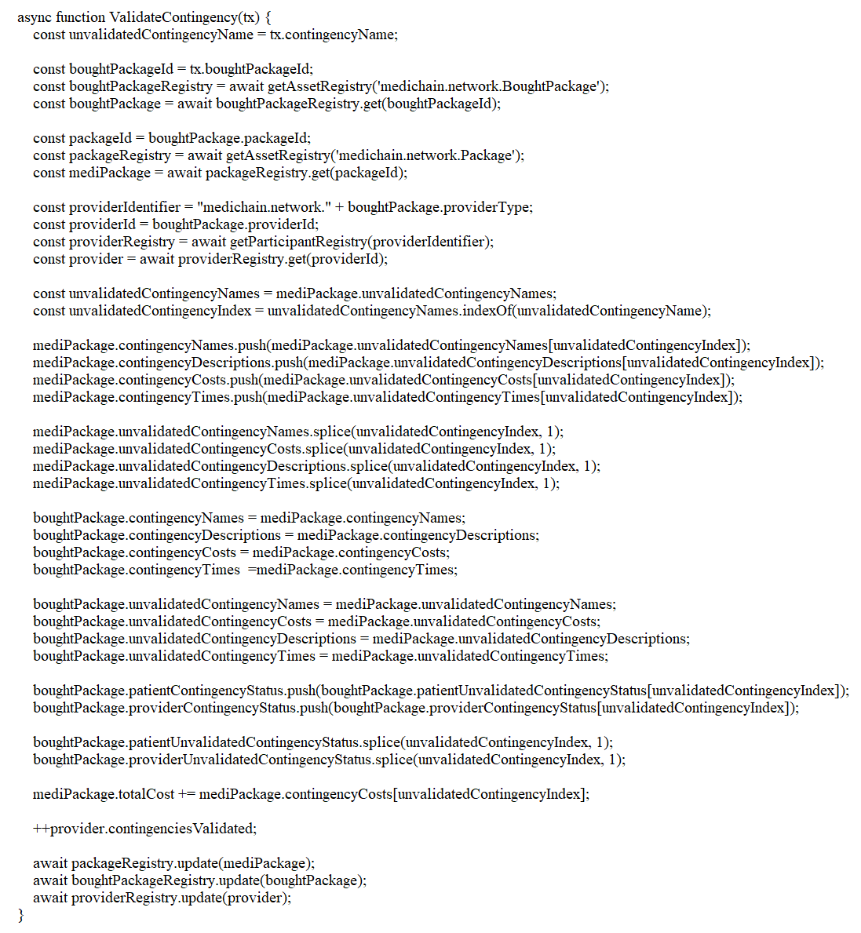
Fig. 15: Chaincode for validation of a contingency by third-party validator

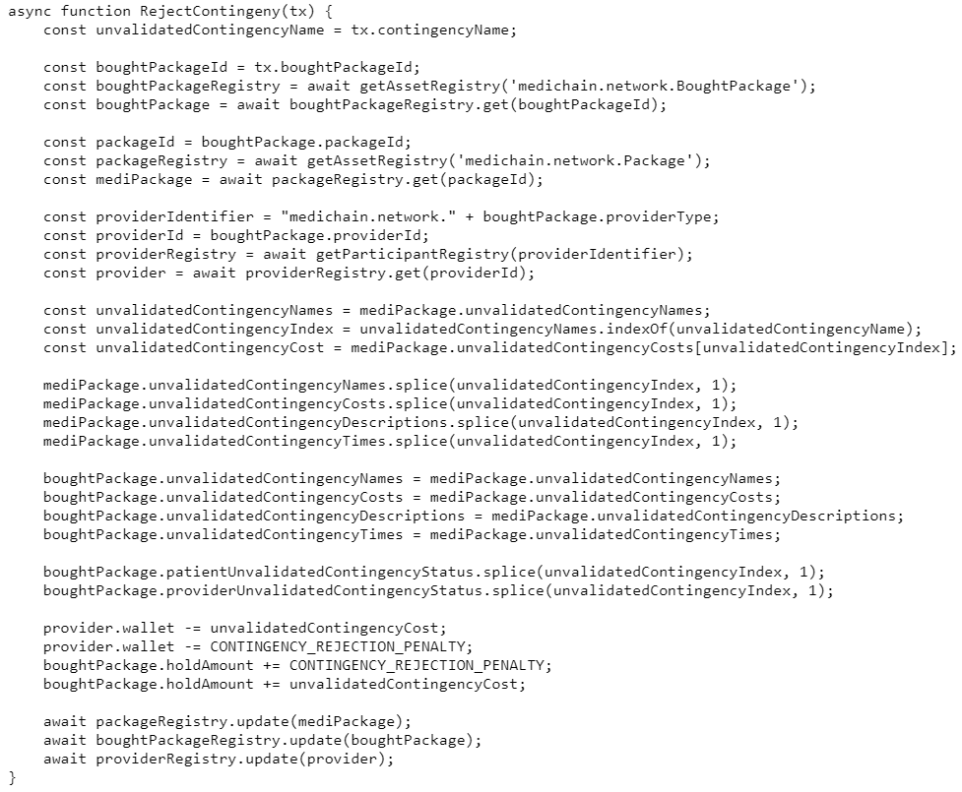
Fig. 16: Chaincode for rejection of contingency by third-party validator

Thus, such a system allows any medical provider to join the network and offer medical services to foreign patients. It thus creates a free market which will naturally keep the prices in check. This differentiates it from the status quo, where MTFs can collude with some providers, allowing price inflation, precluding the existence of a truly free market.

Prototype & Results
The process flow for a typical medical tourism value chain is demonstrated in this section. Screen captures of the AngularJS based interface are accompanied with each step in the process flow.

First, a medical provider would put up a complete medical treatment package that a patient can opt for by paying the total cost. This includes the costs for both the fundamental procedures in the plan as well the contingency procedures (ones that may or may not be required). Fig 9. shows the page for the provider to enter details about the package to be put up. Fig. 10 shows the page through which a patient can sign up for a treatment package.
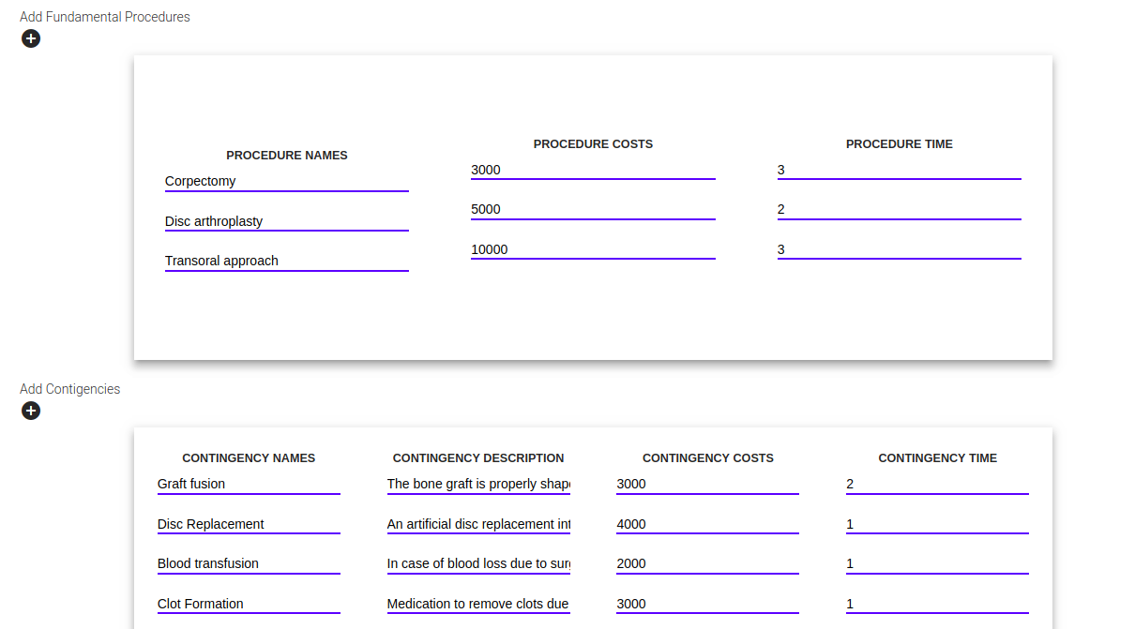
Fig. 17: Page for provider to put up a new package

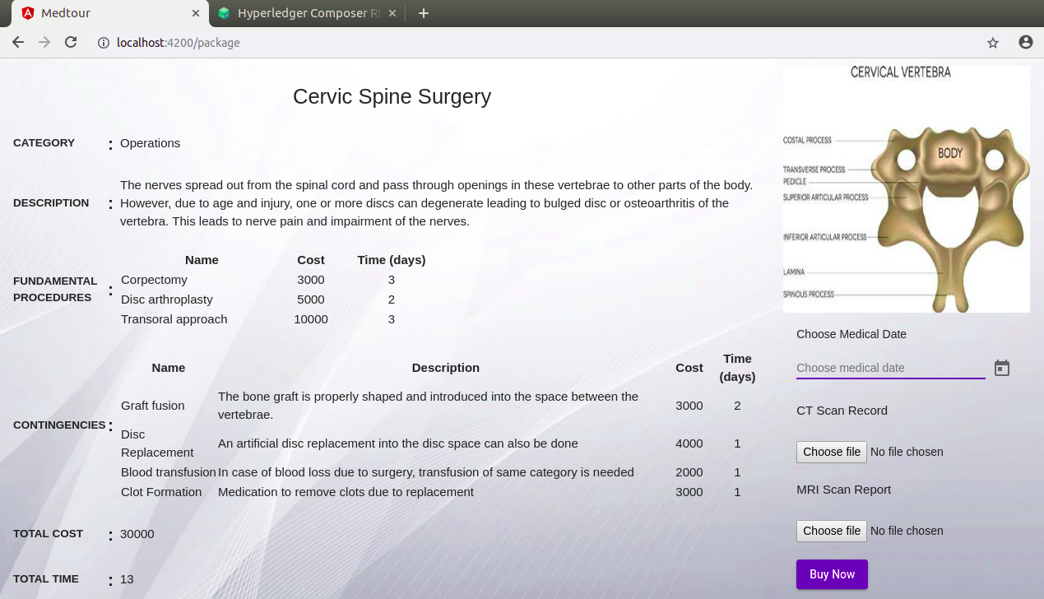
Fig. 18: Page for patient to sign up for a treatment package

A patient will opt for the treatment package by paying the entire amount upfront. In addition to the fundamental amount, a contingency fund is also paid for to accommodate contingency procedures. This money is put into escrow in the form of a Composer asset, which also includes other attributes like dates of procedures. The payment shall happen through a trusted payment gateway system, which is not incorporated in the prototype for the sake of brevity. Fig. 11 shows the JSON representation of the asset created.

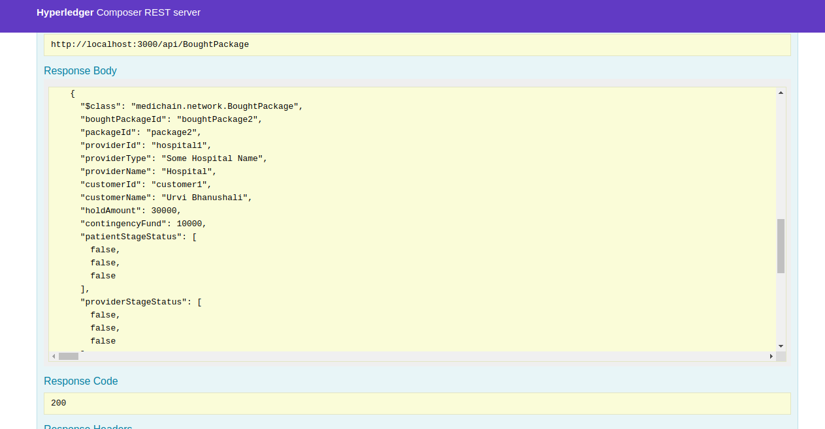
Fig. 19: JSON representation of the Composer asset

The treatment is delivered in stages, with each stage having a corresponding medical procedure associated with it. First, the completion of the procedure is confirmed by the medical provider. This can be done by enabling the corresponding checkbox for that procedure on the page displaying the current status of the transaction. Fig. 12 provides an illustration.

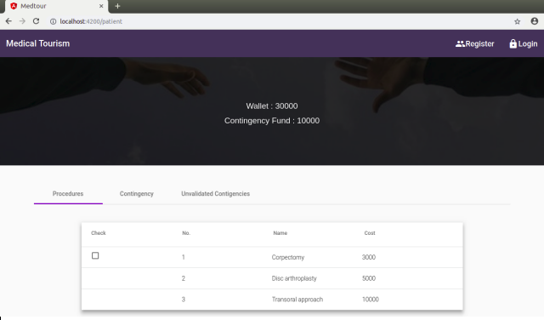
Fig. 20
Then, the patient verifies the same, and the amount of funds designated for that procedure are transferred from the escrow to the wallet of the provider. This enables mutual verification, which helps mitigate the lack of trust between patients and providers. Figures 13 and 14 illustrate this procedure.

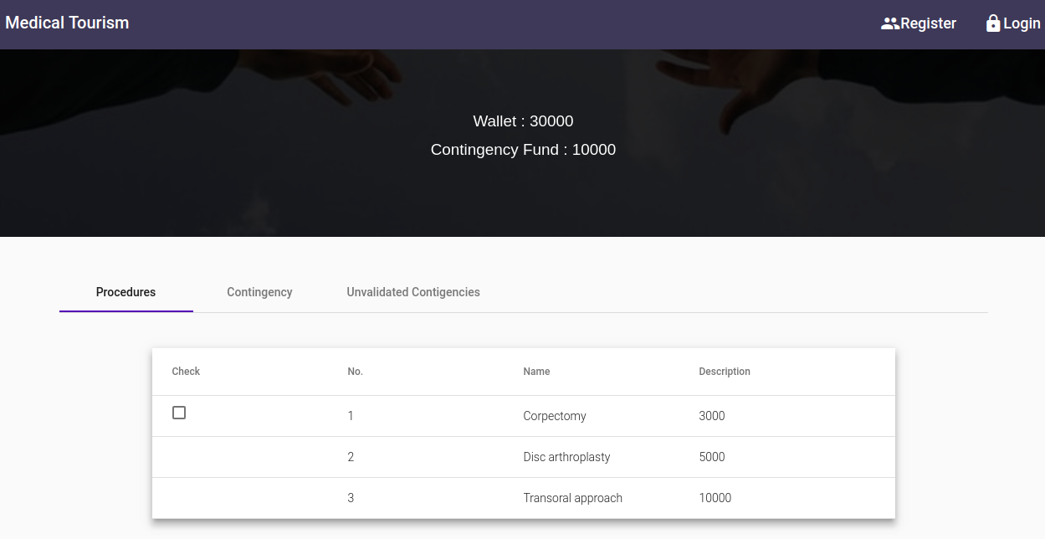 Fig21: Pre-Verification

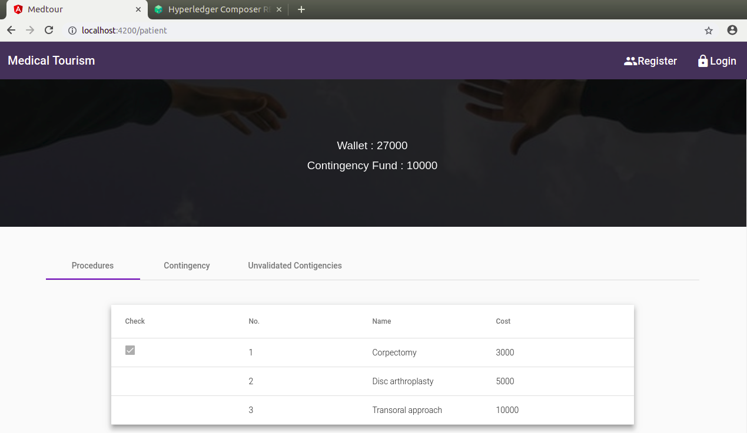
Fig. 22: Post Verification; Funds have been deducted

During the ongoing treatment, the provider can declare the need for a contingency procedure. The interface for this is displayed in Fig. 15. The contingency procedure is dealt with like a regular stage procedure, with the transfer of funds occurring only after the mutual verification described above is completed. However, until validation of the procedure by a third-party validator occurs, it is labelled as unvalidated. Fig. 16 illustrate this.

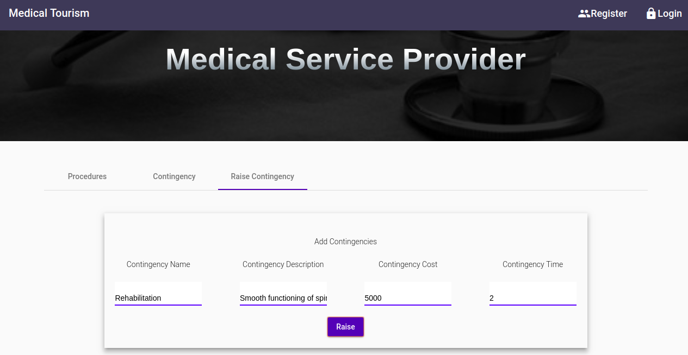
Fig. 23

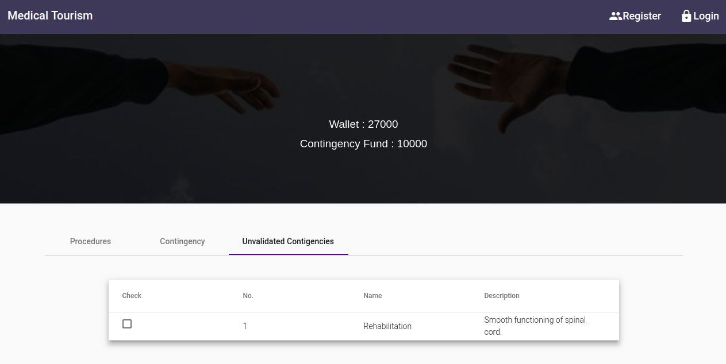
Fig. 24

A contingency procedure must undergo validation by at least one of the third-party validators that were mentioned in the earlier section. Upon successful validation, the procedure is incorporated with the package permanently as one of its prelisted contingencies. Validation can be conferred through the interface shown in Fig. 17.

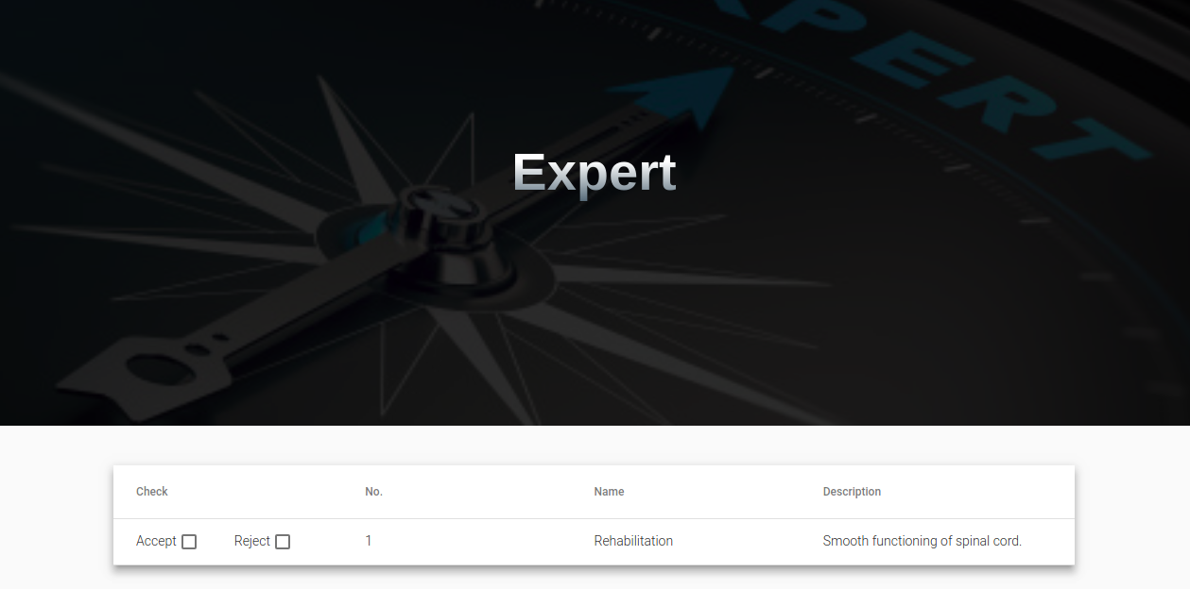
Fig. 25

Upon failing to get validated, however, the patient is refunded the cost of the procedure as well as a reimbursement amount, and the provider is penalized with the same amount.

Finally, upon successful completion of the entire list of stages, the contract is fulfilled, and the corresponding Composer asset is made inactive. Any remnant funds are returned to the patient.

Limitations and Scope for Future Work
The problem framing methodology utilised in this work is VFT. While VFT is an extremely comprehensive and constructive method to frame objectives and derive goals, there may be other techniques that frame problems equally well, if not better. One limitation of the VFT technique is that if one doesn’t consider all stakeholders, an entire set of objectives may be completely ignored. As a result, a strategic goal thus derived may not meet the needs of each and every stakeholder. It is possible that the MT value chain may expand to include stakeholders not considered here. Another possible limitation of the solution proposed here pertains to hospital chains that have privatised end-to-end MT value chains. There is opacity by design in these value chains, and on-boarding of such stakeholders could prove to be troublesome.
According to the research proposed in this paper, an interesting scope of study could be the application of blockchain technology in the unorganised sectors of healthcare such as health tourism pertaining to alternative medicine (homeopathy, acupuncture and so on) as a specific focus. Another area of research could be based on understanding the economic effects of creating disintermediation through blockchains in an industry that owes a lot of its growth to intermediaries in the first place.

Conclusion
This research introduces a disruptive solution to an industry which is being hampered by issues with respect to trust, transparency and a rising degree of intermediation. It also combines an innovative approach to problem framing, called VFT, to define a set of clear objectives and goals. This approach helps accommodate the perspectives, concerns and interests of a comprehensive set of stakeholders, ensuring a holistic solution. The proposed prototype ensures disintermediation through the execution of smart contracts, the terms of which are mutually pre-determined. It increases clarity in communication, trust and transparency by ensuring that transactions are mutually acceptable before being approved. It also caters for the possibility of costs rising above and beyond the standard agreed upon by accommodating for contingency costs and corresponding payments within the smart contracts. It also facilitates collaboration between caregivers, service providers and the Government, for improved accountability. Finally, the work presented here represents an innovative application of blockchain technology in a domain that requires greater accountability and transparency.

Acknowledgement
The completion of the prototype would not have been possible without the use of open source technologies which we were able to leverage. We would like to express our sincere gratitude to the Linux Foundation for the Hyperledger Framework and Google for Angular.

We would also like to thank the various stakeholders who spoke to us and were extremely kind with their time. They were integral to the VFT aspect of our research methodology and we immensely value their contributions.

Appendix

Questions asked to stakeholders as part of VFT interviews:

For Patient:
- Why overseas?
- Why India (any country)?
- How important is good accommodation for the patient?
- How important is good accommodation for companions?
- Would you ignore other foibles in your travel if proper treatment is delivered?
- How off the actual cost turned out to be from your initial estimation?
- List down a few things that would make you not travel to a foreign country again?
- Was the language barrier an issue? How major?
- Rank these items with respect to essentiality in your travel: (rate each item out of 10)
- Proper Treatment
- Trust for the medical personnel
- Trust for other personnel
- Food
- Complete cost of treatment
- Local Travel
- The clarity in interaction with medical personnel
- Clarity in interaction with other personnel
- Physical security
- Accomodation
- Local weather
- Affordability of bringing along multiple companions
- Availability of conventional tourist activities at the destination
- Please mention any other factors positively/negatively affecting a patient’s experience. If possible provide a rating of it’s impact out of 10.
- Did you have to go through any procedure that was not part of the initial package? How much did it inflate your final cost of treatment?
- What would be a deal-breaker for you? (i.e. anything that would discourage you from availing treatment in a foreign country)
- Was it important that your destination also serves as a tourist location? How important?
- Is transparency in the procedure important?
- What aspects, when improved, would result in a more transparent procedure?
- Did a lower cost also lower the quality of your experience? If yes, which aspects exactly?
- According to you, what changes can be made in the process that would make more patients opt for foreign treatments?
- Would you return to this country for further treatment in this same procedure or a different procedure altogether?

For Doctor/Physician :
- How many medical tourists have you treated
- In your opinion is medical tourism beneficial to the MTs
- In your opinion is the process transparent enough
- How do patients reach her
- The average cost for medical tourist?
- How off the actual cost turned out to be from your initial estimation? For her patients.
- Every year is the trend increasing?
- Sourcing medical history
- Follow up treatment -- who is responsible
- What can be done to promote medical tourism
- Barriers in communication?
- Have you ever dealt with MTFs
- Do you think MTFs act ethically
- Have you ever recommended treatment for patients for which they need to travel
- Do MTs complain about conditions in the destination country
- Would you prefer a system that dispensed payment for patients as they went
- Would you prefer a system that makes stakeholders accountable
- Would you prefer a system that guarantees the integrity of medical records of an overseas patient
- Does she charge more to foreign patients?
- Difference in cost?

For MFT:
- What countries do patients mostly come from?
- Are the procedures opted by them emergency treatments or elective / non-emergency?
- From an agent’s perspective, it is important that patients receive a detailed and fully transparent account of the transactions involved in the procedures?
- According to you, is there a need to make the current system more transparent to the patients and other stakeholders involved?
- What aspects of the system can be improved to increase levels of transparency?
- From your experience, what are some deal-breakers for patients? (i.e. anything that discourages patients from pursuing the treatment)?
- Can you list down all things that act as incentives for patients to pursue foreign medical treatment?
- From your experience, rate these items in terms of essentiality in a patient’s travel: (rate on a scale of 10)
- Proper Treatment
- Trust for the medical personnel
- Trust for other personnel
- Food
- Complete cost of treatment
- Local Travel
- The clarity in interaction with medical personnel
- Clarity in interaction with other personnel
- Physical security
- Accomodation
- Local weather
- Affordability of bringing along multiple companions
- Availability of conventional tourist activities at the destination
- Please mention any other factors positively/negatively affecting a patient’s experience. If possible provide a rating of it’s impact out of 10.
- Are patients willing to ignore other foibles in their travel if proper treatment is delivered?
- Is it important that the destination also served as a tourist location for the patients? How important?
- Are there different options/plans available for patients in cost terms? How do these different plans differ in terms of services provided?
- Describe the distribution of patients opting for these different plans (are there more patients opting for the cheaper plans? or is the distribution uniform?)
- Do the patients complain about the conditions in the destination country?
- According to you, do patients leave the country satisfied and willing to return if treatment is required again?
- According to you, what changes can be made in the process that would make more patients opt for foreign treatments?

References
Androulaki, E., Barger, A., Bortnikov, V., Cachin, C., Christidis, K., De Caro, A., … Manevich, Y. (2018). Hyperledger fabric: A distributed operating system for permissioned blockchains. Proceedings of the Thirteenth EuroSys Conference, 30. ACM.
Azaria, A., Ekblaw, A., Vieira, T., & Lippman, A. (2016). Medrec: Using blockchain for medical data access and permission management. 2016 2nd International Conference on Open and Big Data (OBD), 25–30. IEEE.
Balaban, V., & Marano, C. (2010). Medical tourism research: A systematic review. International Journal of Infectious Diseases, 14, e135. https://doi.org/10.1016/j.ijid.2010.02.1784
Baliga, A. (2017). Understanding blockchain consensus models. In Persistent.
Beladi, H., Chao, C.-C., Ee, M. S., & Hollas, D. (2019). Does Medical Tourism Promote Economic Growth? A Cross-Country Analysis. Journal of Travel Research, 58(1), 121–135. https://doi.org/10.1177/0047287517735909
Bramstedt, K. A., & Xu, J. (2007). Checklist: passport, plane ticket, organ transplant. American Journal of Transplantation, 7(7), 1698–1701.
Burkett, L. (2007). Medical tourism. Concerns, benefits, and the American legal perspective. The Journal of Legal Medicine, 28(2), 223–245. https://doi.org/10.1080/01947640701357763
Carrera, P. M., & Bridges, J. F. (2006). Globalization and healthcare: Understanding health and medical tourism. Expert Review of Pharmacoeconomics & Outcomes Research, 6(4), 447–454.
Change Healthcare Case Study. (2019). Retrieved June 28, 2019, from Hyperledger website: https://www.hyperledger.org/resources/publications/changehealthcare-case-study
Connell, J. (2006). Medical tourism: Sea, sun, sand and… surgery. Tourism Management, 27(6), 1093–1100.
Connell, J. (2013). Contemporary medical tourism: Conceptualisation, culture and commodification. Tourism Management, 34, 1–13.
Crooks, V. A., Turner, L., Snyder, J., Johnston, R., & Kingsbury, P. (2011). Promoting medical tourism to India: Messages, images, and the marketing of international patient travel. Social Science & Medicine (1982), 72(5), 726–732. https://doi.org/10.1016/j.socscimed.2010.12.022
Crosby, M., Pattanayak, P., Verma, S., & Kalyanaraman, V. (2016). Blockchain technology: Beyond bitcoin. Applied Innovation, 2(6–10), 71.
De Arellano, A. B. R. (2007). Patients without borders: The emergence of medical tourism. International Journal of Health Services, 37(1), 193–198.
Dhillon, G., & Torkzadeh, G. (2001). Value-Focused Assessment of Information System Security in Organizations. Inf. Syst. J., 16, 293–314. https://doi.org/10.1111/j.1365-2575.2006.00219.x
Eggertson, L. (2006). Wait-list weary Canadians seek treatment abroad. CMAJ : Canadian Medical Association Journal, 174(9), 1247. https://doi.org/10.1503/cmaj.060219
Ehrbeck, T., Guevara, C., & D Mango, P. (2008). Mapping the market for medical travel.
Ferrer, M., & Medhekar, A. (2017). The Factors Impacting on the Management of Global Medical Tourism Service Supply Chain. GSTF Journal on Business Review (GBR), 2(2). Retrieved from http://dl6.globalstf.org/index.php/gbr/article/view/673
Galvin, D. (2017). IBM and Walmart: Blockchain for Food Safety. PowerPoint Presentation.
Gan, L. L., & Frederick, J. R. (2011). Medical tourism facilitators: Patterns of service differentiation. Journal of Vacation Marketing, 17(3), 165–183. https://doi.org/10.1177/1356766711409181
García-Altés, A. (2005). The development of health tourism services. Annals of Tourism Research, 32(1), 262–266.
Hall, C. M. (2011). Health and medical tourism: A kill or cure for global public health? Tourism Review, 66(1/2), 4–15.
Heung, V. C. S., Kucukusta, D., & Song, H. (2010). A Conceptual Model of Medical Tourism: Implications for Future Research. Journal of Travel & Tourism Marketing, 27(3), 236–251. https://doi.org/10.1080/10548401003744677
Hopkins, L., Labonté, R., Runnels, V., & Packer, C. (2010). Medical tourism today: What is the state of existing knowledge? Journal of Public Health Policy, 31(2), 185–198. https://doi.org/10.1057/jphp.2010.10
Keckley, P. H., & Underwood, H. R. (2008). Medical tourism: Consumers in search of value. Washington: Deloitte Center for Health Solutions.
Keeney, R. L. (1993). Creativity in MS/OR: Value-Focused Thinking—Creativity Directed toward Decision Making. INFORMS Journal on Applied Analytics, 23(3), 62–67. https://doi.org/10.1287/inte.23.3.62
Keeney, R. L. (1994, July 15). Creativity in Decision Making with Value-Focused Thinking. Retrieved June 4, 2019, from MIT Sloan Management Review website: https://sloanreview.mit.edu/article/creativity-in-decision-making-with-valuefocused-thinking/
Keeney, R. L., & McDaniels, T. L. (1992). Value-Focused Thinking about Strategic Decisions at BC Hydro. INFORMS Journal on Applied Analytics, 22(6), 94–109. https://doi.org/10.1287/inte.22.6.94
Korcok, M. (1997). Excess demand meets excess supply as referral companies link Canadian patients, US hospitals. Cmaj, 157(6), 767–770.
Lee, H. K., & Fernando, Y. (2015). The antecedents and outcomes of the medical tourism supply chain. Tourism Management, 46, 148–157. https://doi.org/10.1016/j.tourman.2014.06.014
Lin, I.-C., & Liao, T.-C. (2017). A Survey of Blockchain Security Issues and Challenges. IJ Network Security, 19(5), 653–659.
MacReady, N. (2007). Developing countries court medical tourists. The Lancet, 369(9576), 1849–1850. https://doi.org/10.1016/S0140-6736(07)60833-2
Mamun, M. Z., & Andaleeb, S. S. (2013). Prospects and Problems of Medical Tourism in Bangladesh. International Journal of Health Services, 43(1), 123–141. https://doi.org/10.2190/HS.43.1.i
Marlowe, J., & Sullivan, P. (2007). Medical tourism: The ultimate outsourcing. Human Resource Planning, 30, 8–10.
Martínez Álvarez, M., Chanda, R., & Smith, R. D. (2011). The potential for bi-lateral agreements in medical tourism: A qualitative study of stakeholder perspectives from the UK and India. Globalization and Health, 7(1), 11. https://doi.org/10.1186/1744-8603-7-11
Mattila, J. (2016). The blockchain phenomenon. Berkeley Roundtable on the International Economy (BRIE), 2016–1.
Medical Tourism Industry Valued at $100B Poised for 25% Year-Over-Year Growth by 2025. (2016). Retrieved July 4, 2019, from https://www.medicaltourismmag.com/article/medical-tourism-industry-valued-at-439b-poised-for-25-year-over-year-growth-by-2025
Medical Tourism Market - Global Industry Analysis, Size, Share, Growth, Trends, and Forecast 2017 - 2025. (2017). Retrieved June 26, 2019, from https://www.mrrse.com/medical-tourism
Medical Tourism Statistics & Facts | Patients Beyond Borders. (2011, July 12). Retrieved June 9, 2019, from https://patientsbeyondborders.com/medical-tourism-statistics-facts
Mettler, M. (2016). Blockchain technology in healthcare: The revolution starts here. 2016 IEEE 18th International Conference on E-Health Networking, Applications and Services (Healthcom), 1–3. IEEE.
Milstein, A., & Smith, M. (2006). America’s New Refugees — Seeking Affordable Surgery Offshore. The New England Journal of Medicine, 355, 1637–1640. https://doi.org/10.1056/NEJMp068190
Mingxiao, D., Xiaofeng, M., Zhe, Z., Xiangwei, W., & Qijun, C. (2017). A review on consensus algorithm of blockchain. 2017 IEEE International Conference on Systems, Man, and Cybernetics (SMC), 2567–2572. https://doi.org/10.1109/SMC.2017.8123011
Morais, D. C., Alencar, L. H., Costa, A. P. C. S., & Keeney, R. L. (2013). Using value-focused thinking in Brazil. Pesquisa Operacional, 33(1), 73–88. https://doi.org/10.1590/S0101-74382013000100005
Mudur, G. (2003). India plans to expand private sector in healthcare review. BMJ: British Medical Journal, 326(7388), 520.
Nakamoto, S. (2008). Bitcoin: A Peer-to-Peer Electronic Cash System. 9.
Nguyen, Q. K. (2016). Blockchain-a financial technology for future sustainable development. 2016 3rd International Conference on Green Technology and Sustainable Development (GTSD), 51–54. IEEE.
Ølnes, S., Ubacht, J., & Janssen, M. (2017). Blockchain in government: Benefits and implications of distributed ledger technology for information sharing. Elsevier.
Park, J., & Park, J. (2017). Blockchain security in cloud computing: Use cases, challenges, and solutions. Symmetry, 9(8), 164.
Peterson, M. (2018). Blockchain and the Future of Financial Services. The Journal of Wealth Management, 21(1), 124–131. https://doi.org/10.3905/jwm.2018.21.1.124
PricewaterhouseCoopers. (2019, June 5). Blockchain is here. What’s your next move? Retrieved June 6, 2019, from PwC website: https://www.pwc.com/gx/en/issues/blockchain/blockchain-in-business.html
Seebacher, S., & Schüritz, R. (2017). Blockchain technology as an enabler of service systems: A structured literature review. International Conference on Exploring Services Science, 12–23. Springer.
Selart, M., & Johansen, S. T. (2011). Understanding the Role of Value-Focused Thinking in Idea Management. Creativity and Innovation Management, 20(3), 196–206.
Shukla, S., Mohanty, B. K., & Kumar, A. (2018). Strategizing sustainability in e-commerce channels for additive manufacturing using value-focused thinking and fuzzy cognitive maps. Industrial Management & Data Systems, 118(2), 390–411. https://doi.org/10.1108/IMDS-03-2017-0122
Smith, M., & Puczko, L. (2008). Health and Wellness Tourism. Routledge.
Turner, L. (2007). ‘First World Health Care at Third World Prices’: Globalization, Bioethics and Medical Tourism. BioSocieties, 2(3), 303–325. https://doi.org/10.1017/S1745855207005765
Unti, J. A. (2009). Medical and surgical tourism: The new world of health care globalization and what it means for the practicing surgeon. Bulletin of the American College of Surgeons, 94(4), 18–25.
Vukolić, M. (2017). Rethinking Permissioned Blockchains. Proceedings of the ACM Workshop on Blockchain, Cryptocurrencies and Contracts - BCC ’17, 3–7. https://doi.org/10.1145/3055518.3055526
Whittaker, A. (2008). Pleasure and pain: Medical travel in Asia. Global Public Health, 3(3), 271–290. https://doi.org/10.1080/17441690701463936
Yli-Huumo, J., Ko, D., Choi, S., Park, S., & Smolander, K. (2016). Where is current research on blockchain technology?—a systematic review. PloS One, 11(10), e0163477.
Zambrano, R., Young, A., & Verhulst, S. (2018). Connecting Refugees to Aid through Blockchain-Enabled ID Management: World Food Programme’s Building Blocks.
Zheng, Z., Xie, S., Dai, H., Chen, X., & Wang, H. (2017). An Overview of Blockchain Technology: Architecture, Consensus, and Future Trends. 2017 IEEE International Congress on Big Data (BigData Congress), 557–564. https://doi.org/10.1109/BigDataCongress.2017.85

